**Leoncio U. Coronado Jr.**  
+63298874425  
[coronadonoell@gmail.com](mailto:coronadonoell@gmail.com)

Git Hub URL : https://github.com/FirstNoell/my-portfolio-amazon.git

**Professional Summary**

Detail-oriented Data Science Intern with extensive experience in Python, Selenium, and Scrapy, specializing in automating data collection and deriving actionable insights from large datasets. Known for a strong passion for workflow optimization and a keen ability to extract valuable information from dynamic web sources, including e-commerce platforms with JavaScript-heavy frameworks. Enthusiastic about contributing to innovative solutions and continuously expanding technical expertise.

**Skills**

* **Programming Languages:** Python, SQL, HTML, CSS
* **Data Science Tools:** Pandas, NumPy, Matplotlib
* **Web Scraping Tools:** Selenium, Scrapy, BeautifulSoup
* **Databases:** SQLite, MongoDB

**Education**

**Data Science Short Course**  
Udemy  
*Date of Completion: September 21, 2024*

**Certificates of Completion**

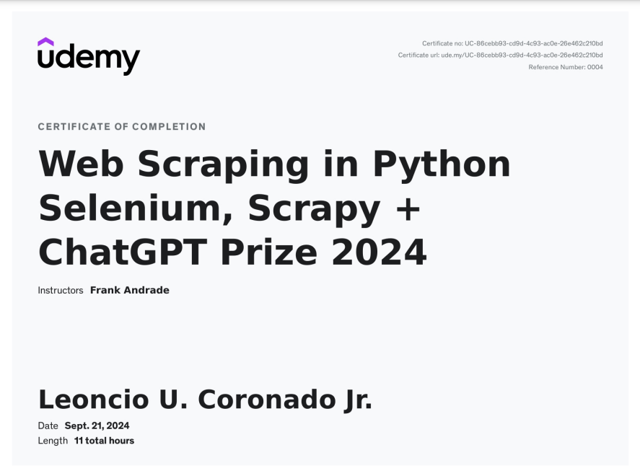

**Work Experience**

**Freelance Data Science Intern**  
*June 2023 – Present*

* Assisted with data collection, cleaning, and analysis for various client projects, focusing on web scraping and data automation.
* Developed automated web scraping scripts using Python and Selenium to gather extensive datasets from websites with heavy JavaScript frameworks, including e-commerce sites like Amazon.
* Analyzed and visualized data trends, providing actionable insights for stakeholders.
* Collaborated with team members to implement machine learning models to predict key metrics.

**Projects**

**Gas Prices Scraping Project**  
*August 2024*

* Created a Scrapy spider to collect gas prices for various states from the AAA Gas Prices website, including current, yesterday’s, and year-ago averages.
* Employed Selenium to interact with dynamic web elements, ensuring accurate data extraction.
* Stored scraped data in a SQLite database for efficient querying and analysis.  
  *Tools:*  Selenium, SQLite

**Movie Transcripts Scraping Project**  
*September 2024*

* Developed a Scrapy spider to extract movie transcripts from Subslikescript.com.
* Parsed and structured data to retrieve titles, plots, and URLs, saving results in a well-organized SQLite database.
* Automated the scraping process to run on a schedule, regularly updating the database with new entries.  
  *Tools:* Scrapy, SQLite

**E-commerce Product Scraping Project Using Scrapy and Splash  
October 2024**

**• Designed and implemented a web scraping solution to extract product data from Amazon, utilizing Scrapy and Splash to handle JavaScript-rendered content.  
• Configured Splash to render JavaScript elements and integrated it with Scrapy to efficiently retrieve product titles, prices, ratings, link and other key details from Amazon’s dynamically loaded pages.  
• Developed a custom pipeline to clean and store the scraped data in a MongoDB database, enabling advanced querying and facilitating competitive market analysis.  
Tools: Scrapy, Splash, MongoDB**Compiled and stored the scraped data in a MongoDB database for advanced querying and analysis, facilitating competitive market research.  
*Tools:* Selenium, BeautifulSoup, Scrapy, MongoDB

**Reddit Data Analysis Project Using Scrapy and Splash**  
**November,2024**

• Developed a Scrapy spider integrated with Splash to collect data from Reddit posts, including titles, user comments, upvotes, and timestamps, overcoming JavaScript-rendered content on subreddit pages.  
• Configured Splash to render JavaScript-heavy content, enabling effective data extraction from dynamically loaded elements on Reddit pages.  
• Utilized custom pipelines to preprocess and store the scraped data in a SQLite database for easy querying and analysis.  
• Applied natural language processing (NLP) techniques to analyze comment sentiment and visualize trends, providing actionable insights into user sentiment and popular topics on Reddit.  
**Tools**: Scrapy, Splash, SQLite, Pandas, NLTK, Matplotlib

**Languages**

* English
* Filipino